ritmos:

R1-↓↑↓-↓↑↓

R2-↓↑↓-↓-↑

R3-↓↑↓-↓↑↓↑

R4-↓-↓↑↓-↑↓↑

R5-↓-↓↓-(↓↑↓↑-↓)x3

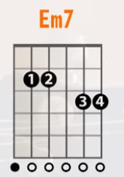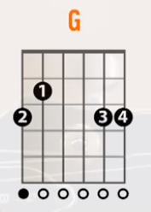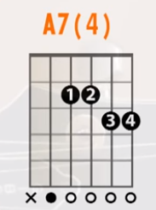

riff 1 riff 2 riff 3 riff 4 riff 5

---------- ---------- ---------- ---------- ----------

---------- -0-------- ---------- ---0------ ----------

-----0-2-- ---2-0---- -------0-2 -2---2-0-- -2-0------

-0h2------ ---------- ---0h2---- ---------- -----2-0--

---------- ---------- -3-------- ---------- ----------

riff 6

----------

----------

----------

-----0----

-0h2------

----------

riff1 Em7R1 riff2 GR2 riff3 Em7R3 riff4 GR2 riff3 Em7R3 riff5 A7(4)R4 riff1 Em7R3 riff5 A7(4)R4 riff6 GR5